# **ECOMMERCE WEBSITE DEVELOPMENT**

INTRODUCTION:

Create an eCommerce website with cloud computing. In this phase we design the ecommerce website called “EATWELL”. The general conditionds and the steps involved in designing the ecommerce website are given below.

**Homepage:**

A welcoming introduction to your website.

High-quality images of delicious food.

A search bar for users to quickly find what they want.

**Menu:**

Categorized list of food options (e.g., appetizers, main courses, desserts).

Brief descriptions and images for each item.

Price information.

**Ordering System:**

An online ordering system that's user-friendly.

Quick order placement and payment options.

Delivery or pickup choices.

**Contact and Support:**

Contact information for customer support.

Live chat or chatbot for quick replies to user queries.

**Food Varieties:**

Showcase a wide range of cuisines and dishes.

Include dietary preferences (e.g., vegetarian, vegan, gluten-free).

**User Reviews and Ratings:**

Allow users to leave reviews and ratings for each dish.

Build trust through social proof.

**Blog or Food Articles:**

Publish articles about food, recipes, and culinary tips.

Engage users with interesting content.

**About Us:**

Information about your restaurant or food service.

The story behind your passion for food.

Here the steps and functions option are showed:

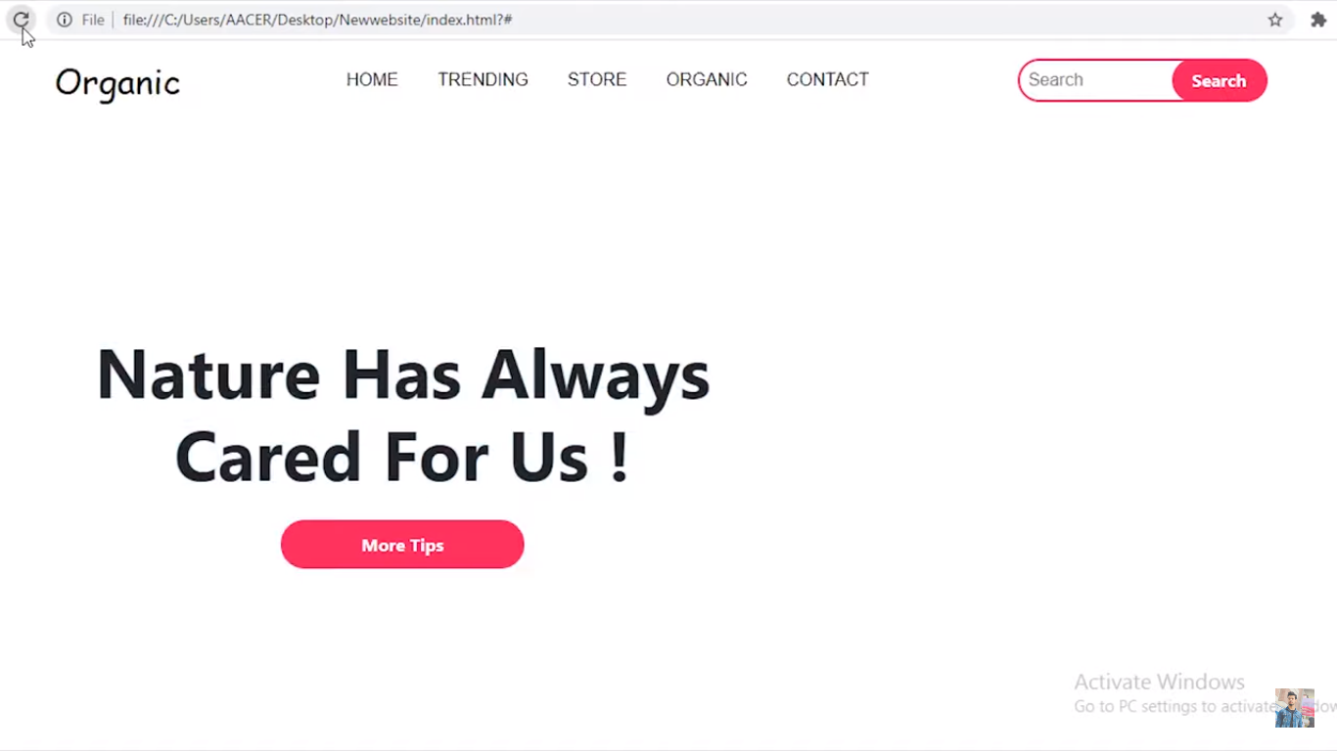

The process has shown here the background picture has been inserted:

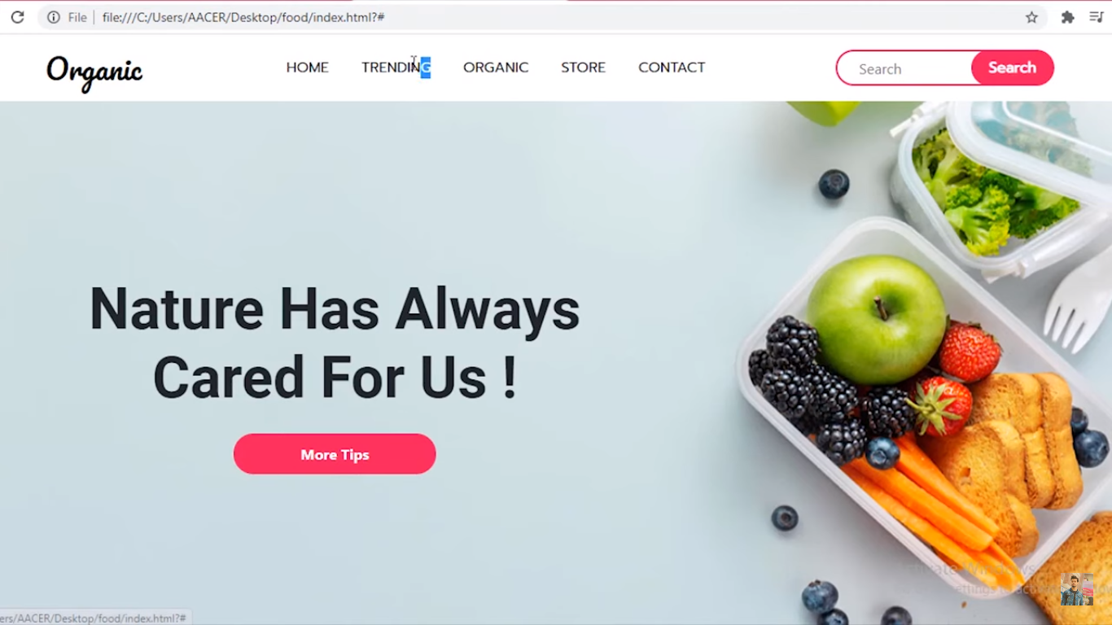

Certain codes:

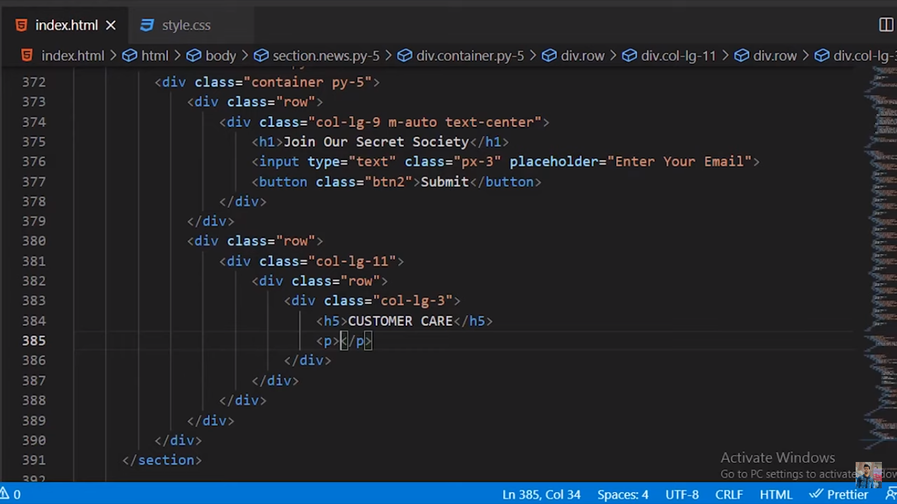

The website are using visual studio code.

The second page of website is done. After clicking the more tips option from previous page.

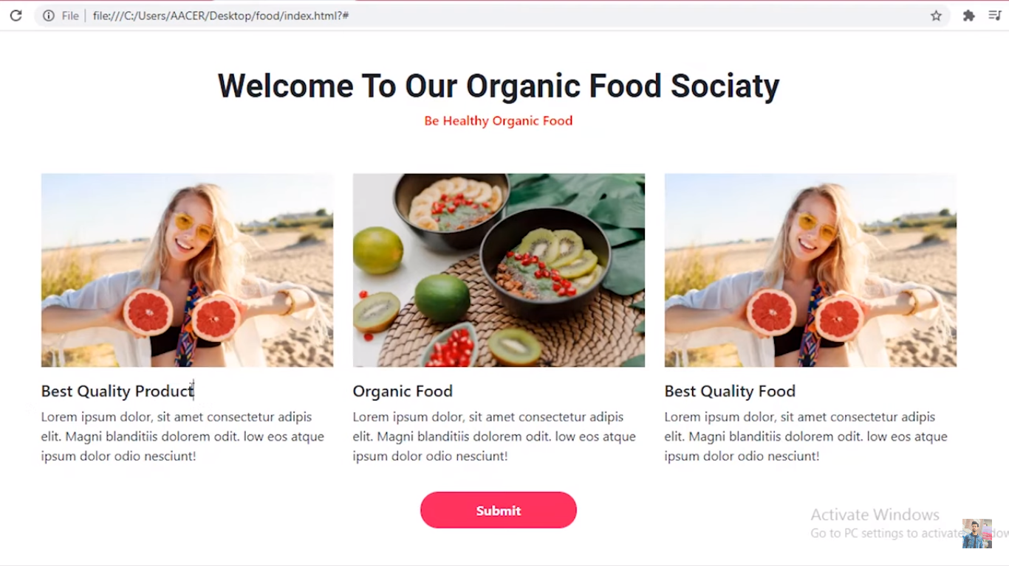

By function buttons the page can be changed.

Here there are more options to select to move to next page.

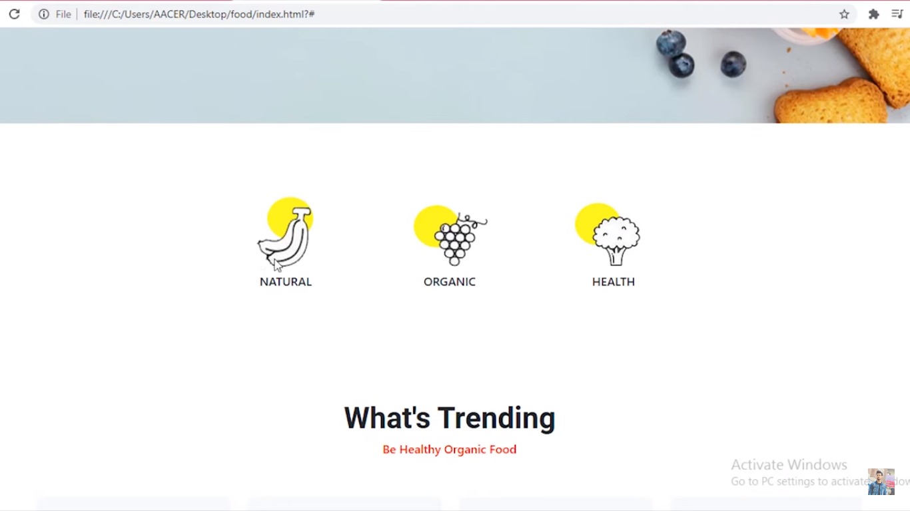

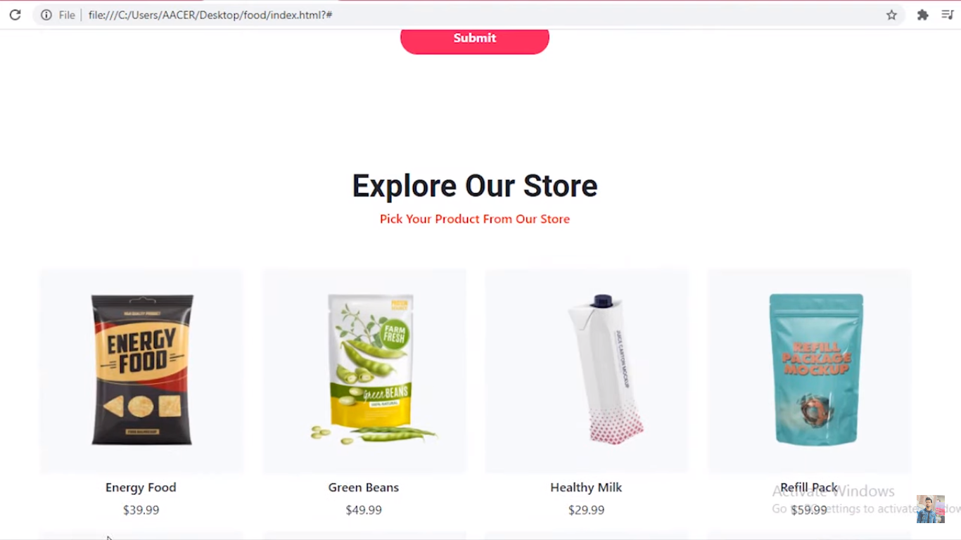

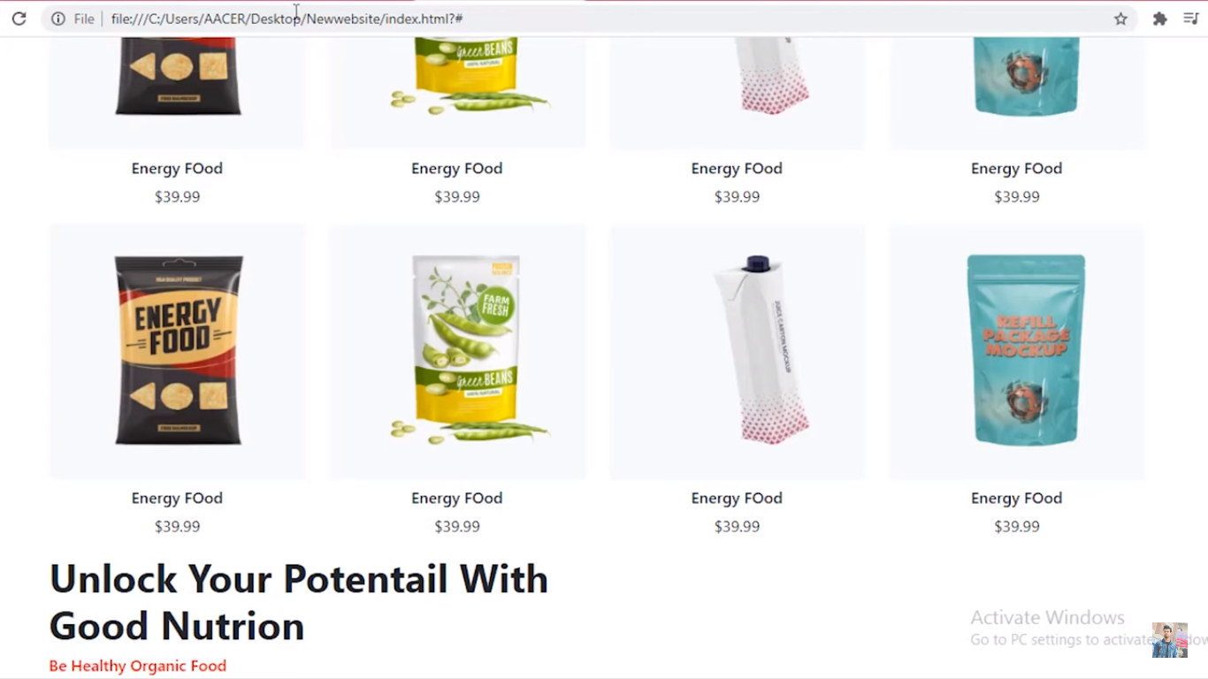

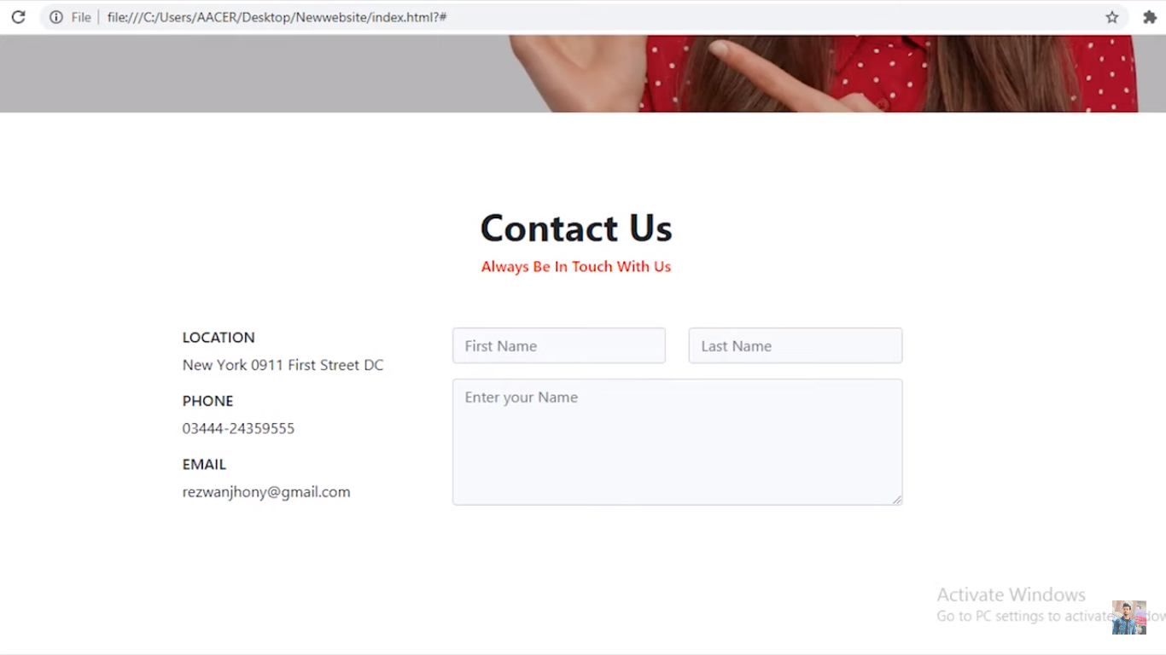

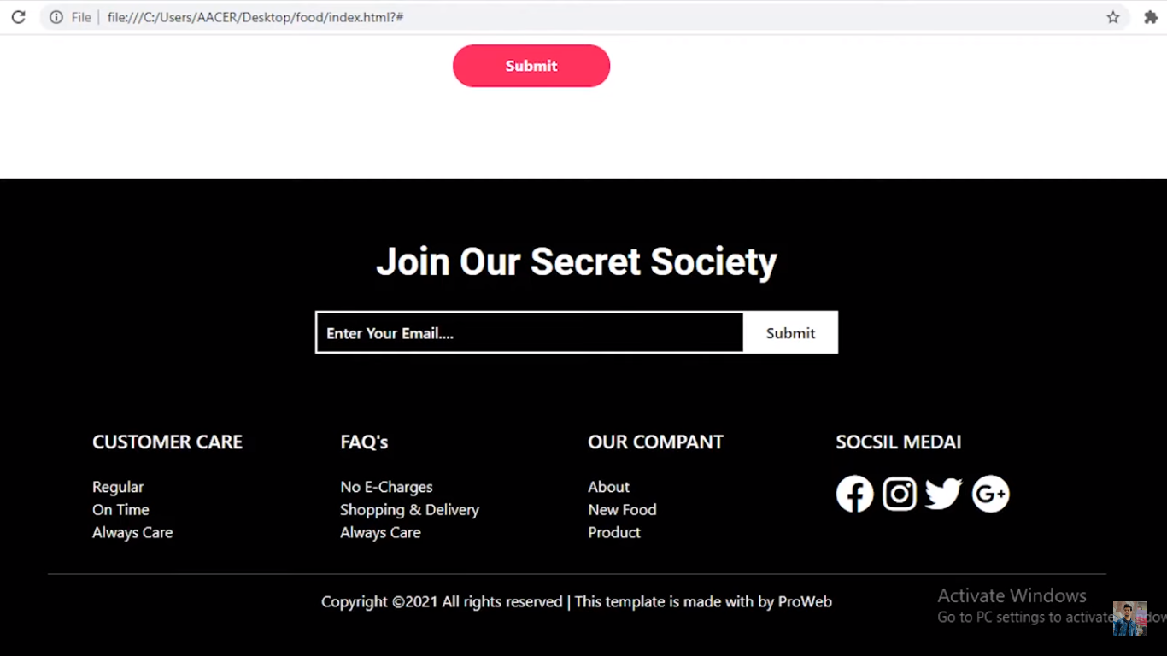

The **order&delivery eCommerce website** would provide the delivery services in addition to simply ordering the meals. This means you would have to hire some local couriers or partner with some delivery chains, but this would allow you to charge more for the orders done while growing the table turnover rates and profits for both the restaurants and the delivery businesses. On the other hand, you would be saving valuable time for their customers, so it is a win-win situation for all the parties involved.